M.ANUSIYA

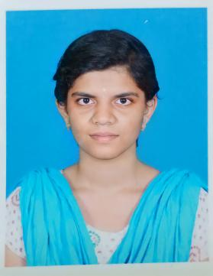

**Phone no :** 8754891839

**Email ID :** [**anusiyam52@gmail.com**](mailto:anusiyam52@gmail.com)

**OBJECTIVE**

* To obtain a challenging position to the best utilization of my skills and looking for oppurtunities to grow my technical and managerial skills and ready to fulfill organizational goals.

**ACADEMIC DETAILS**

|  |  |  |  |  |
| --- | --- | --- | --- | --- |
| **SPECIFICATION** | **PASSING YEAR** | **INSTITUTION** | **STREAM** | **PERCENTAGE** |
| B.E | 2023 | Annapoorana Engineering College | Computer Science and Engineering | 7.81  CGPA |
| HSC | 2019 | Tagore Matric Higher Secondary School | Bio Maths | 77% |
| SSLC | 2017 | Govt. Girls Higher Secondary School | General | 97% |

**TECHNICAL SKILLS**

* Programming languages : C , C++ , Basics in JAVA
* Frontend : Basics in HTML,CSS
* Backend : PHP
* Database : Basics in MYSQL
* MS office
* Handle “Turbo c” software and “visual studio”.

**OTHER SKILLS**

* Ability to work both independently and as a team player.

**STRENGTH**

* Good listener
* Quick learner
* Positive attitude

**ACHIEVEMENTS**

1. Attended one week inplant training in “Techforge Academy”.
2. Attended one day industrial visit in “codebind Technologies” in Coimbatore.
3. Completed certificate course in “Advanced Diploma in Java Programming(ADJP)” with 5 month course duration.
4. Completed certificate course in “Mobile app development”.
5. I have done a mini project “Temperature and Humidity monitoring system**”.**

**PERSONAL DETAILS**

DATE OF BIRTH : 15.10.2001

GENDER : Female

MARITAL STATUS : Single

ADDRESS : Attur, Salem-636001

**LANGUAGES KNOWN**

TAMIL : (read,write,speak)

ENGLISH : (read,write,speak)

**DECLARATION**

**I hereby declare that all the information furnished above is correct and best to my knowlwdge.**

**DATE :**

**PLACE : Salem**

**Signature**

M.Anusiya